**Unit 1 Movie Database Design**

Corey Crooks

Purdue University Global

IT234 – Leon King

May 19, 2021

Unit 1 Movie Database Design

For this assignment, I chose the following entities to represent the excel spreadsheet: Movie, Director, and LeadStar. The Movie Entity would have 5 attributes (Singh, 2021) consisting of MovieTitle, IMDbScore, Genre, StarID, and DirectorID. The Director Entity would have 3 attributes including DirectorID, FirstName, and LastName. Similarly, the LeadStar entity would have 3 attributes consisting of StarID, FirstName, and LastName. The ID tags for each director and star would relate to where they are used in the Movie entity as foreign keys (Rabelo, 2020).

The relationships in these tables with the ID’s are necessary as primary and foreign keys in order to provide distinction and stability. Let’s say Tom Hanks had a son, and decided to name him Tom Richards Hanks. Since this database does not have any space to put middle names, this new actor would be labeled similarly to his father; Tom Hanks. In such an event, we wouldn’t be able to distinguish Tom Richards Hanks from his father Tom Hanks. To solve this, we can put an StarID at the start of each record in order to distinguish each actor and actress from each other regardless of any other information we receive. This same situation applies for the Director entity, so we will need an ID there too. Since each star or director only gets a single record in their respective tables, we can use these ID’s as a primary key, as they are guaranteed to be unique. Using these identifiers in the Movie table further increases our consistency, and enables us to keep director and star works consistent no matter potential name duplicates.

Movie Database Visio Layout

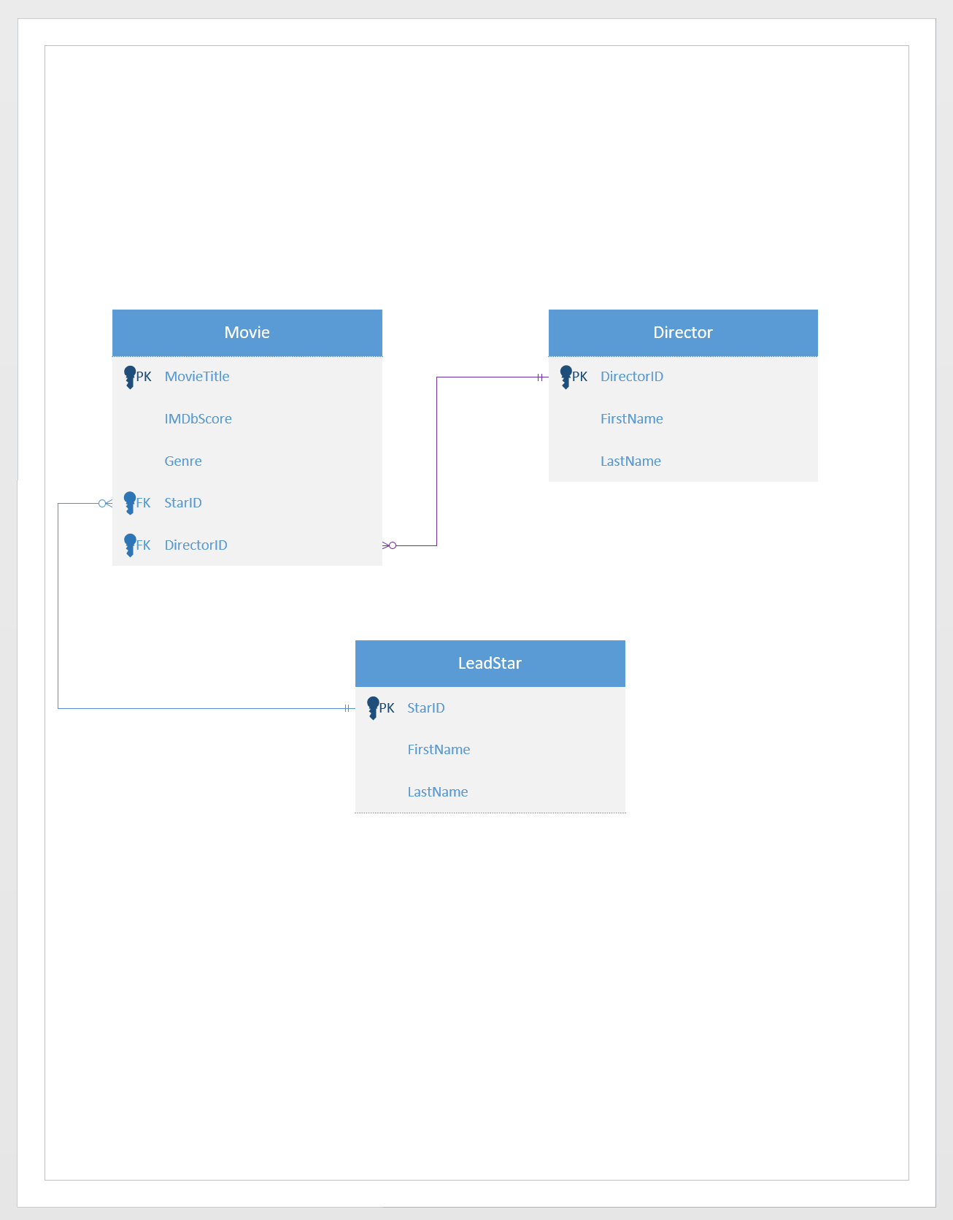

# **References**

Rabelo, J. (2020, August 14). *Foreign Key*. Retrieved from Techopedia: https://www.techopedia.com/definition/7272/foreign-key#:~:text=A%20foreign%20key%20is%20a,establishing%20a%20link%20between%20them.

Singh, C. (2021, May 13). *What is an attribute in DBMS? – Definition and explanation*. Retrieved from BeginnersBook: https://beginnersbook.com/2015/05/definition-attribute-dbms/